ЛАБОРАТОРНА РОБОТА №1-2

ТЕМА: БАЗОВІ КОНЦЕПЦІЇ WPF

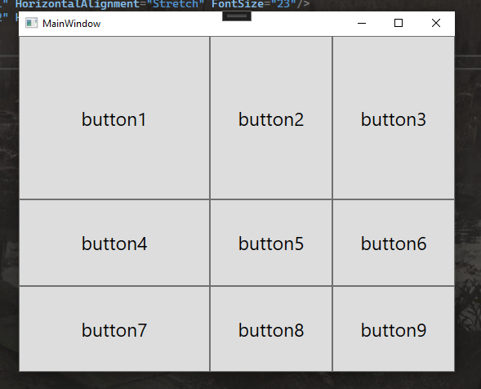

| <Window x:Class="WpfApp1.MainWindow"  xmlns="http://schemas.microsoft.com/winfx/2006/xaml/presentation"  xmlns:x="http://schemas.microsoft.com/winfx/2006/xaml"  xmlns:d="http://schemas.microsoft.com/expression/blend/2008"  xmlns:mc="http://schemas.openxmlformats.org/markup-compatibility/2006"  xmlns:local="clr-namespace:WpfApp1"  mc:Ignorable="d"  Title="MainWindow" Height="450" Width="550">  <Grid Name ="grid1">  <Grid.RowDefinitions>  <RowDefinition Height="200"/>  <RowDefinition Height="*"/>  <RowDefinition Height="*"/>  </Grid.RowDefinitions>  <Grid.ColumnDefinitions>  <ColumnDefinition Width="*"/>  <ColumnDefinition Width="150"/>  <ColumnDefinition Width="150"/>  </Grid.ColumnDefinitions>  <Button Name="button1" Content="button1" Grid.Row="0" Grid.Column="0" HorizontalAlignment="Stretch" FontSize="23"/>  <Button Name="button2" Content="button2" Grid.Row="0" Grid.Column="1" HorizontalAlignment="Stretch" FontSize="23"/>  <Button Name="button3" Content="button3" Grid.Row="0" Grid.Column="2" HorizontalAlignment="Stretch" FontSize="23"/>  <Button Name="button4" Content="button4" Grid.Row="1" Grid.Column="0" HorizontalAlignment="Stretch" FontSize="23"/>  <Button Name="button5" Content="button5" Grid.Row="1" Grid.Column="1" HorizontalAlignment="Stretch" FontSize="23"/>  <Button Name="button6" Content="button6" Grid.Row="1" Grid.Column="2" HorizontalAlignment="Stretch" FontSize="23"/>  <Button Name="button7" Content="button7" Grid.Row="2" Grid.Column="0" HorizontalAlignment="Stretch" FontSize="23"/>  <Button Name="button8" Content="button8" Grid.Row="2" Grid.Column="1" HorizontalAlignment="Stretch" FontSize="23"/>  <Button Name="button9" Content="button9" Grid.Row="2" Grid.Column="2" HorizontalAlignment="Stretch" FontSize="23"/>  </Grid>  </Window> |
| --- |